How to Make Marching Band Payments on Charms

- Go to www.charmsoffice.com
- Click on Parents/Students/Members Login.
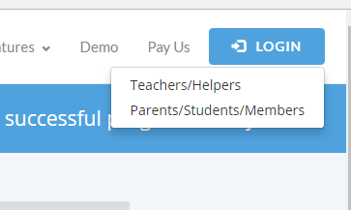

3. The school code is Freeband.
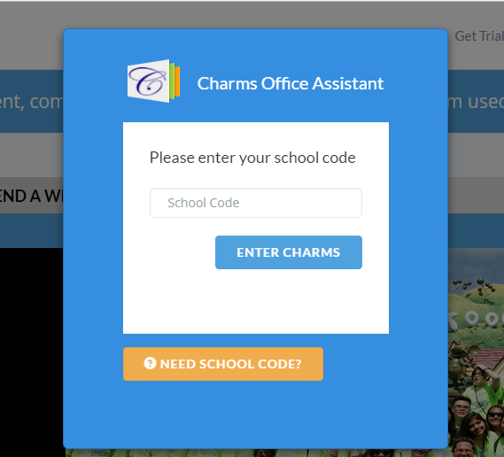
4. Enter your password to gain access to your account.
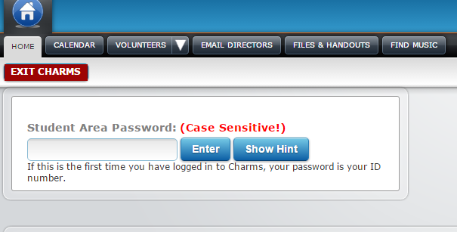
5. Click on the Online Store.
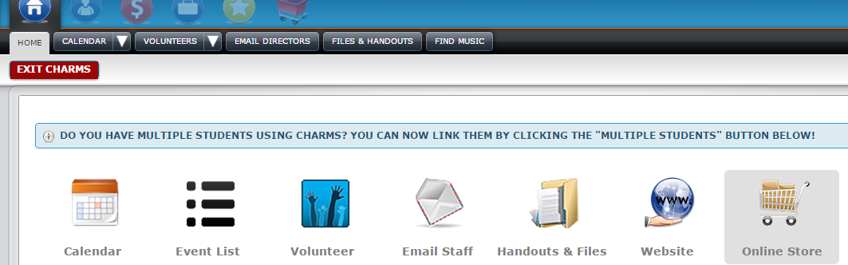

6. Click on the green button for the 2017 Marching Band Deposit.

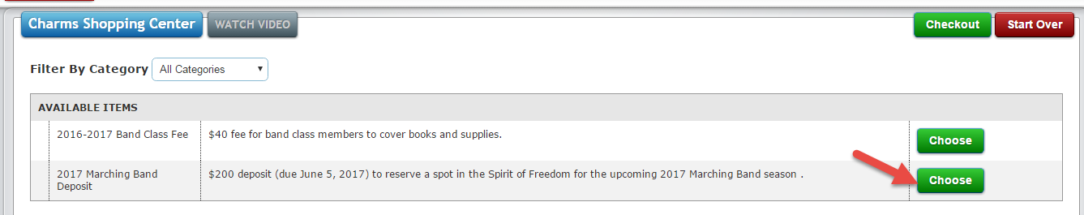

7. Click on the $200.
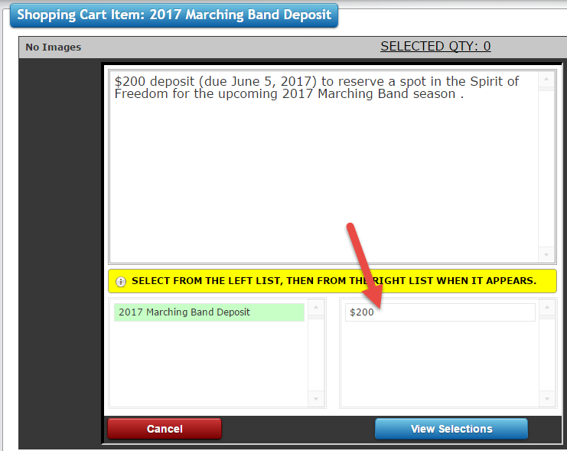

8. Click on Update Cart.
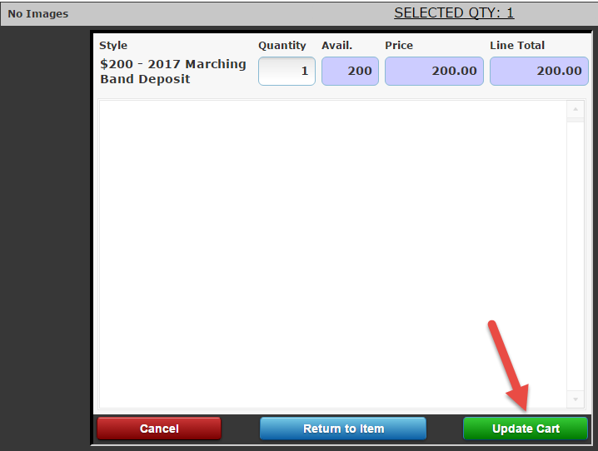

9. Click on Checkout.
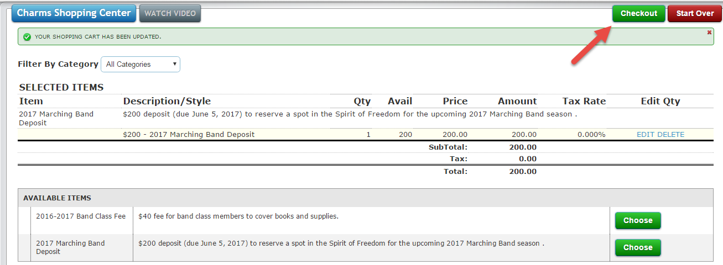

10. Click on “choose a payment option”, and choose Affinipay in the drop down menu.
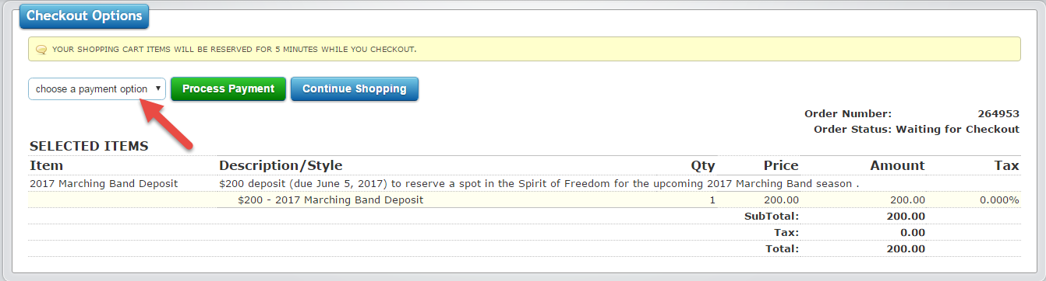

11. Click on Process Payment.
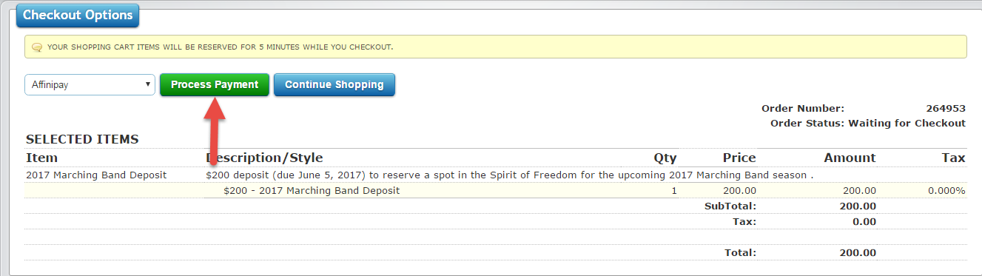

12. Fill in your credit card information and finish with clicking on Complete Checkout. A receipt will be emailed to you.

