How to Make the Final Marching Band Payment
Due July 31, 2017
Log onto Charms, and click on the “Finances” icon.
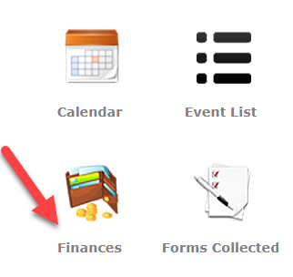

The $200 owed is highlighted in red. Follow the red arrow and click on AffiniPay to pay online.
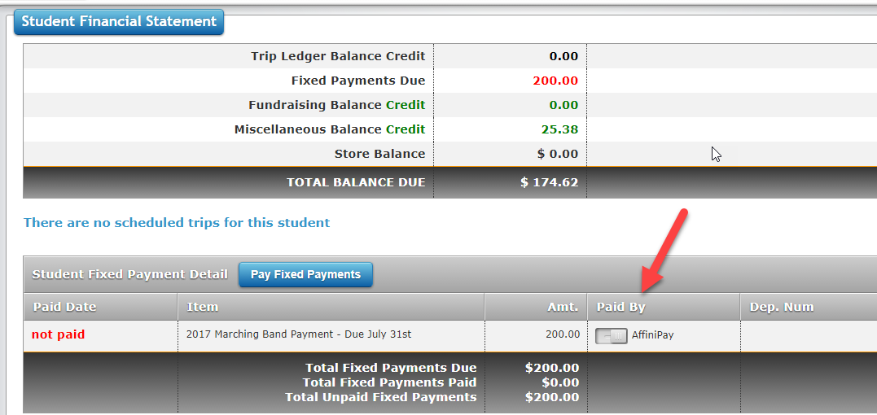

The AffiniPay button and it will turn blue.
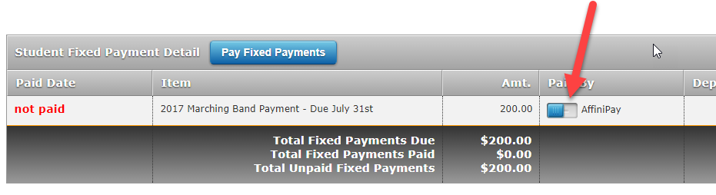
Click on the “Pay Fixed Payments”.
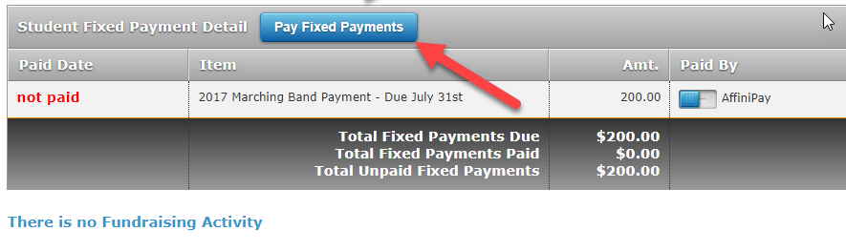
Fill in the requested information.
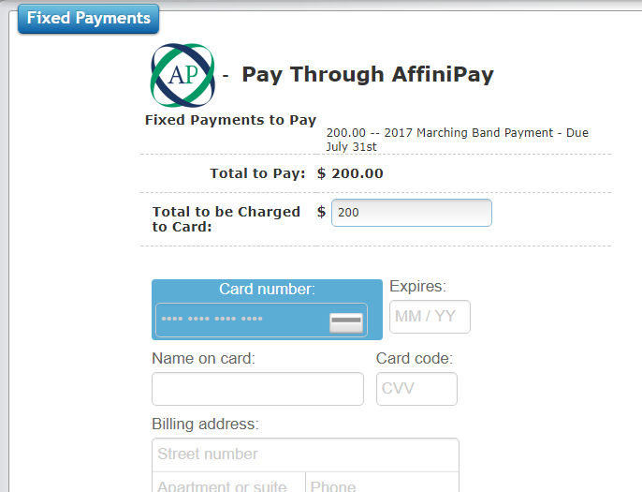

Upon providing the requested information, click on the green “Start Payment” button at the bottom of the screen.
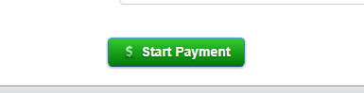

Which will lead to the screen showing the payment has been received.

