2017-2018 Spirit of Freedom Marching Band
Season Information Packet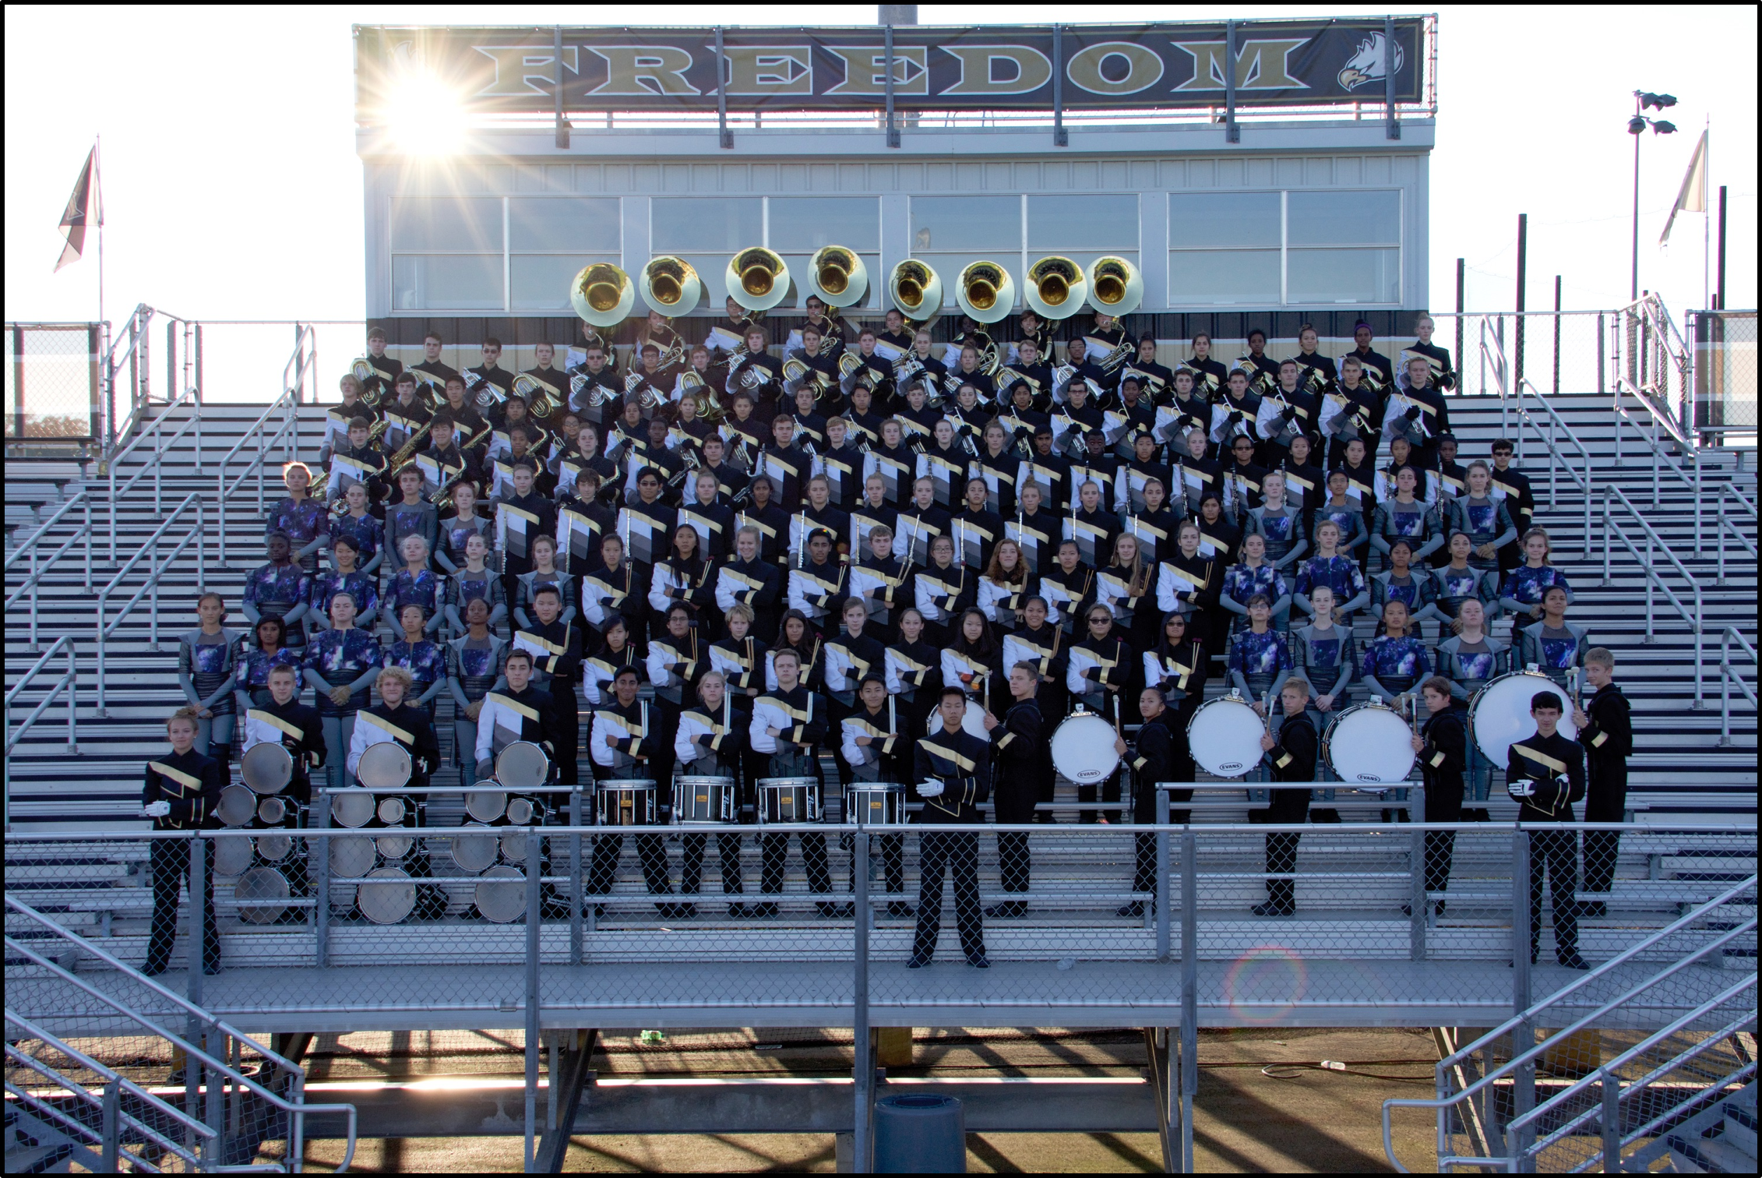
It is my pleasure to invite you to become a part of the award-winning Spirit of Freedom! The Freedom High School Marching Band is a great activity that helps develop confidence, positive attitude, self-esteem, cooperation, and self-discipline. It also gives members the thrill of performing in a great band in front of lots of enthusiastic fans. It takes a great deal of time, discipline, and dedication; however, the rewards are well worth the effort.
Watch this video for a glimpse into the 2016 Spirit of Freedom season:
https://youtu.be/uNJWjcYvF1E
WHAT IS THE SPIRIT OF FREEDOM?
More than 150 members strong, the Spirit of Freedom is one of the largest and most popular co-curricular activities at Freedom High School. Marching Band consists of brass, woodwind, and percussion players plus a color guard. The band performs at home football games on Friday nights and in competitions on many Saturdays through early November. Marching Band is encouraged but not required for students enrolled in the band classes. Summer practices include four rehearsals in late July/early August and Band Camp the rest of August until school starts. Percussion and Color Guard members have an additional mandatory camp held on July 31-August 4. Band Camp attendance in its entirety is required for all Marching Band members.

WHEN ARE TRYOUTS?
Friday, June 2, 6:00 – 9:00 PM – Also includes a parent meet and greet presented by the Freedom High School Band Boosters.
Saturday, June 3, 9:00 AM – 12:00 PM
Monday, June 5, 6:00 – 9:00 PM – Deposit payment and commitment form are due at the final tryout session.
PROSPECTIVE CANDIDATES MUST ATTEND ALL THREE SESSIONS. These are essentially the first three rehearsals of the season and serve as an introduction to Marching Band techniques. Basic music, marching, and movement skills will be taught.
Please bring water, wear athletic-type clothing, and be prepared for lots of physical activity. We will be outside if the weather permits.
Contact Mr. Galway if you have any conflicts
Tryout results will be one of the following three categories:
- Regular Member: Full-time position in the competition show. Members will be re-evaluated for regular and reserve positions in Band Camp as well as throughout the season. Percussionists will be assigned to specific instruments; brass and woodwind players will be assigned to a 1st, 2nd, or 3rd part if applicable.
- Reserve Member: Reserve members initially serve as backup performers and do not have a full-time position in the competition show. Reserve members can earn a position in the competition show if a regular member becomes drops out, becomes injured, or fails to meet expectations. They will attend all performances, trips, rehearsals, and band camp. Members will be re-evaluated for regular and reserve positions in Band Camp as well as throughout the season.
- Not Accepted: It is possible that a very small percentage of students will not be accepted into the marching band if there are basic deficiencies in playing and movement skills, or if the curricular class requirement is not met for brass, woodwind, and percussion players (see below).

WHO IS ELIGIBLE FOR PARTICIPATION?
BRASS AND WOODWINDS: Membership is open to any student who has a minimum of two years of experience playing a brass or woodwind instrument. Members of the brass and woodwind sections must be enrolled in a band class.
PERCUSSION: The percussion section consists of the Battery and the Front Ensemble:
- The Battery consists of snare, multi-tenor, and bass drum. Membership is competitive and a strong percussion background is needed.
- The Front Ensemble consists of grounded percussion instruments including xylophone, glockenspiel, marimba, vibraphone, accessory percussion, timpani, and electronic keyboard synthesizer. Membership is open to any student who has keyboard percussion, auxiliary percussion, or piano skills.
Membership into the percussion section requires a minimum of two years of musical experience as a part of a band, orchestra, guitar, or chorus class and the ability to read standard musical notation. Members must be enrolled in a music class (band, orchestra, guitar, or choir) Students who play a brass or woodwind instrument will not be accepted into the percussion section.
COLORGUARD: The Color Guard is a movement-based section that provides additional visual aspects to the show through the use of flag spinning, rifles, sabers, and dance. Membership is open to any FHS student. While prior dance experience is helpful, it is not mandatory.

WHAT IS THE SCHEDULE AND ATTENDANCE POLICY?
Dates in yellow are mandatory rehearsals for everyone (full band)
Dates in cyan are mandatory for percussion
Dates in green are mandatory for color guard
Dates in fuchsia are mandatory for brass and woodwinds
Dates in orange are mandatory for student leaders
Dates in red are performances and are mandatory for everyone
Dates in blue are important fundraisers. If we do not meet our fundraising expectations, we will have to raise the fee or cut trips out of our schedule
Dates that are not highlighted are OK to miss if you are out of town. Please send Mr. Galway an email prior to any absence
Band Camp starts on August 7 and is the most important event of the season. The band learns fundamentals and 90% of the competition show during these three weeks. Members are expected to be present during all Band Camp rehearsals and should not arrive late or leave early. DO NOT schedule vacations, family trips, doctor’s appointments, SAT prep classes, or jobs at times that conflict with Band Camp rehearsals. Members who miss any part of Band Camp may be placed on Reserve Member status or dismissed from the organization.
In addition, members of the Colorguard and Percussion sections are required to attend a section-specific camp held on July 31-August 4. This camp is required for members of those sections.

JULY 2017 (Tentative)
SUN | MON | TUE | WED | THU | FRI | SAT
16 | 17 | 18  PERCUSSION AND COLORGUARD STUDENT LEADERS 4:30 - 5:30 PM  PERCUSSION AND COLORGUARD 6:00 - 9:00 PM | 19 | 20  PERCUSSION AND COLORGUARD STUDENT LEADERS 4:30 - 5:30 PM  PERCUSSION AND COLORGUARD 6:00 - 9:00 PM | 21 | 22
23 | 24 | 25  STUDENT LEADERS 4:30 - 5:30 PM  FULL BAND 6:00 - 9:00 PM | 26 | 27  STUDENT LEADERS 4:30 - 5:30 PM  FULL BAND 6:00 - 9:00 PM | 28 | 29
30 | 31  COLORGUARD 8:00 AM - 4:00 PM  PERCUSSION 8:00 AM - 4:00 PM
AUGUST 2017 (Tentative)
SUN | MON | TUE | WED | THU | FRI | SAT
 |  | 1  COLORGUARD 8:00 AM - 4:00 PM  PERCUSSION 8:00 AM - 4:00 PM  STUDENT LEADERS 4:30 - 5:30 PM  BRASS AND WOODWINDS 6:00 - 9:00 PM | 2  COLORGUARD 8:00 AM - 4:00 PM  PERCUSSION 8:00 AM - 4:00 PM | 3  PERCUSSION 1:00 - 9:00 PM  COLORGUARD 1:00 - 9:00 PM  STUDENT LEADERS 4:30 - 5:30 PM  BRASS AND WOODWINDS 6:00 - 9:00 PM | 4 | 5
6 | 7  NEW MEMBERS AND STUDENT LEADERS 9:00 AM - 12:00 PM  FULL BAND 1:00 - 9:00 PM (BAND CAMP)  STUDENT LEADERS 4:30 - 5:30 PM | 8  FULL BAND (BAND CAMP) 9:00 AM - 9:00 PM  MANDATORY PARENT MEETING 7:00 PM | 9  FULL BAND (BAND CAMP) 9:00 AM - 9:00 PM | 10  FULL BAND (BAND CAMP) 9:00 AM - 9:00 PM  STUDENT LEADERS 4:30 - 5:30 PM | 11  FULL BAND (BAND CAMP) 9:00 AM - 9:00 PM | 12
13 | 14  FULL BAND (BAND CAMP) 9:00 AM - 9:00 PM | 15  FULL BAND (BAND CAMP) 9:00 AM - 9:00 PM  STUDENT LEADERS 4:30 - 5:30 PM | 16  FULL BAND (BAND CAMP) 4:00 PM - 9:00 PM | 17  FULL BAND (BAND CAMP) 4:00 PM - 9:00 PM | 18  FULL BAND (BAND CAMP) 4:00 PM - END OF PREVIEW SHOW  STUDENT LEADERS 2:30 - 3:30 PM  PARENT PREVIEW SHOW 7:00 PM | 19
20 | 21  FULL BAND (BAND CAMP) 4:00 - 9:00 PM | 22  FULL BAND (BAND CAMP) 4:00 - 9:00 PM | 23  FULL BAND (BAND CAMP) 4:00 - 9:00 PM  STUDENT LEADERS 2:30 - 3:30 PM | 24  FIRST DAY OF SCHOOL  BRASS AND WOODWINDS 4:15 - 6:15 PM  PERCUSSION 4:15 - 6:15 PM  COLORGUARD 6:00 - 8:00 PM | 25 | 26  FULL BAND 10:00 AM - 6:00 PM (SUPER SATURDAY)  MATTRESS SALE FUNDRAISER  (Avoid taking the SAT on this date)
27 | 28  STUDENT LEADERS 4:00 - 5:00 PM  PERCUSSION 6:30 - 9:00 PM | 29  BRASS AND WOODWINDS 4:15 - 6:15 PM  COLORGUARD 6:30 - 9:00 PM | 30  FULL BAND 5:00 - 8:00 PM | 31  BRASS AND WOODWINDS 4:15 - 6:15 PM  PERCUSSION 4:15 - 6:15 PM  COLORGUARD 6:00 - 8:00 PM
September 2017 (Tentative)
SUN | MON | TUE | WED | THU | FRI | SAT
 |  |  |  |  | 1  HOME FOOTBALL GAME VS. RIVERSIDE  4:15 - 10:00 PM | 2
3 | 4  NO SCHOOL | 5  BRASS AND WOODWINDS 4:15 - 6:15 PM  PERCUSSION 4:15 - 6:15 PM  COLORGUARD 6:30 - 9:00 PM | 6  FULL BAND 5:00 - 8:00 PM | 7  BRASS AND WOODWINDS 4:15 - 6:15 PM  PERCUSSION 4:15 - 6:15 PM  COLORGUARD 6:00 - 8:00 PM | 8 | 9  TAG DAY FUNDRAISER, TIMES TBD  (Avoid taking the ACT on this date)
10 | 11  STUDENT LEADERS 4:00 - 5:00 PM  PERCUSSION 6:30 - 9:00 PM | 12  BRASS AND WOODWINDS 4:15 - 6:15 PM  COLORGUARD 6:30 - 9:00 PM | 13  FULL BAND 5:00 - 8:00 PM | 14  BRASS AND WOODWINDS 4:15 - 6:15 PM  PERCUSSION 4:15 - 6:15 PM  COLORGUARD 6:00 - 8:00 PM | 15  HOME FOOTBALL GAME VS. LOUDOUN COUNTY 4:15 - 10:00 PM | 16  COMPETITION: USBANDS WESTERN LOUDOUN SHOWCASE AT WOODGROVEHIGH SCHOOL
17 | 18  STUDENT LEADERS 4:00 - 5:00 PM  PERCUSSION 6:30 - 9:00 PM | 19  BRASS AND WOODWINDS 4:15 - 6:15 PM  COLORGUARD 6:30 - 9:00 PM | 20  FULL BAND 5:00 - 8:00 PM | 21  BRASS AND WOODWINDS 4:15 - 6:15 PM  PERCUSSION 4:15 - 6:15 PM  COLORGUARD 6:00 - 8:00 PM | 22 | 23  COMPETITION: USBANDS NORTHERN VIRGINIA REGIONAL AT HERNDON HIGH SCHOOL
24 | 25  STUDENT LEADERS 4:00 - 5:00 PM  PERCUSSION 6:30 - 9:00 PM | 26  BRASS AND WOODWINDS 4:15 - 6:15 PM  COLORGUARD 6:30 - 9:00 PM | 27  FULL BAND 5:00 - 8:00 PM | 28  BRASS AND WOODWINDS 4:15 - 6:15 PM  PERCUSSION 4:15 - 6:15 PM  COLORGUARD 6:00 - 8:00 PM | 28  POSSIBLE AWAY GAME AT BRIAR WOODS HS 4:15 - 10:00 PM | 30
October 2017 (Tentative)

SUN | MON | TUE | WED | THU | FRI | SAT
1 | 2  STUDENT LEADERS 4:00 - 5:00 PM  PERCUSSION 6:30 - 9:00 PM | 3  BRASS AND WOODWINDS 4:15 - 6:15 PM  COLORGUARD 6:30 - 9:00 PM | 4  FULL BAND 5:00 - 8:00 PM | 5  BRASS AND WOODWINDS 4:15 - 6:15 PM  PERCUSSION 4:15 - 6:15 PM  COLORGUARD 6:00 - 8:00 PM | 6  HOME FOOTBALL GAME VS. ROCK RIDGE (HOME-  COMING) 4:15 - 10:00 PM | 7  (OK to take the SAT on this date)
8 | 9  NO SCHOOL | 10  BRASS AND WOODWINDS 4:15 - 6:15 PM  PERCUSSION 4:15 - 6:15 PM  COLORGUARD 6:30 - 9:00 PM | 11  FULL BAND 5:00 - 8:00 PM | 12  BRASS AND WOODWINDS 4:15 - 6:15 PM  PERCUSSION 4:15 - 6:15 PM  COLORGUARD 6:00 - 8:00 PM | 13 | 14  COMPETITION: USBANDS AT WASHINGTON HS, CHARLES TOWN, WV
15 | 16  STUDENT LEADERS 4:00 - 5:00 PM  PERCUSSION 6:30 - 9:00 PM | 17  BRASS AND WOODWINDS 4:15 - 6:15 PM  COLORGUARD 6:30 - 9:00 PM | 18  FULL BAND 5:00 - 8:00 PM | 19  BRASS AND WOODWINDS 4:15 - 6:15 PM  PERCUSSION 4:15 - 6:15 PM  COLORGUARD 6:00 - 8:00 PM | 20 | 21  COMPETITION: VBODA STATE MARCHING ASSESSMENT AND JAMES MADISON UNIVERSITY PARADE OF CHAMPIONS
22 | 23  NO SCHOOL FOR STUDENTS | 24  BRASS AND WOODWINDS 4:15 - 6:15 PM  PERCUSSION 4:15 - 6:15 PM  COLORGUARD 6:30 - 9:00 PM | 25  FULL BAND 5:00 - 8:00 PM | 26  BRASS AND WOODWINDS 4:15 - 6:45 PM  PERCUSSION 4:15 - 6:15 PM  COLORGUARD 6:00 - 8:00 PM | 27  HOME FOOTBALL GAME VS. STONE BRIDGE 4:15 - 10:00 PM | 28  (OK to take the ACT on this date)
29 | 30  STUDENT LEADERS 4:00 - 5:00 PM  PERCUSSION 6:30 - 9:00 PM | 31  BRASS AND WOODWINDS 4:15 - 6:15 PM  COLORGUARD 6:30 - 9:00 PM
NOVEMBER 2017 (Tentative)

SUN | MON | TUE | WED | THU | FRI | SAT
 |  |  | 1  FULL BAND 5:00 - 8:00 PM | 2  BRASS AND WOODWINDS 4:15 - 6:15 PM  PERCUSSION 4:15 - 6:15 PM  COLORGUARD 6:00 - 8:00 PM | 3  HOME FOOTBALL GAME VS. JOHN CHAMPE HS (SENIOR NIGHT) 4:15 - 10:00 PM | 4  COMPETITION: USBANDS MID-ATLANTIC CHAMPS, UNIVERSITY OF MARYLAND, COLLEGE PARK  (Avoid taking the SAT on this date)
5 | 6  NO SCHOOL FOR STUDENTS | 7  NO SCHOOL FOR STUDENTS | 8  FULL BAND 5:00 - 8:00 PM | 9  BRASS AND WOODWINDS 4:15 - 6:15 PM  PERCUSSION 4:15 - 6:15 PM  COLORGUARD 6:00 - 8:00 PM | 10 | 11  COMPETITION: USBANDS NATIONAL CHAMPS. AT METLIFE STADIUM, EAST RUTHERFORD, NJ
12 | 13  END OF SEASON CLEAN-UP AND CHECK-OUT 4:15 - 5:30 PM | 14  AWARDS BANQUET  7:00 PM | 15 | 16 | 17 | 18

Good attendance is VITAL to our success as an organization. You cannot contribute if you are not present. By joining, you are making a commitment to the organization. Everyone is counting on you.
Excused Absences from Rehearsals
✭ Illness ✭ Family Emergency ✭ Religious Observations ✭ Court Summons
✭ Family Vacations (EXCEPT during Band Camp) ✭ Drum Corps
Any type of absence not listed above will be considered unexcused. Students who are absent are expected to devote extra time to get caught up. Students who are chronically absent will be suspended from performing, placed on reserve member status, or dismissed from the organization.
STUDENTS ARE NOT PERMITTED TO MISS PERFORMANCES unless it is an extreme circumstance. Missing performers, even just one, can affect the evaluators’ perception of our show and may hurt us competitively. Please check the calendar carefully to avoid conflicts.

HOW MUCH DOES IT COST?
The Marching Band fee for 2017 will be between $400 - $450. The final cost will depend on the cost of the travel and our fundraising success. The fee covers approximately 75% of the Marching Band’s total expenses for the season. The remaining expenses are covered by the Band Boosters via fundraising (approx. 15%) and LCPS (approx. 10%).
The only other expenses associated with marching band are personal items purchased one time such as:
- Shoes (everyone, approx. $30)
- Water jug (everyone, approx. $15)
- 3-ring binder and sheet protectors (everyone, approx. $10)
- Lyre and flip folder (brass and woodwinds only, approx. $15)
- Mouthpiece, ligature, reeds, etc. (brass and woodwinds only, cost varies)
- Make-up/styling products (colorguard, approx. $20)
- Warm-up suit (colorguard, approx. $100)
- Other small items may come up as needed
The payment schedule is:
- $200 is due by Monday, June 5, the final day of tryouts, along with your Commitment Form. The show will be designed based on the number of deposits received on this date. PLEASE NOTE that once you have paid your deposit and turned in your commitment form, we will consider you an official member of the Spirit of Freedom Marching Band and expect that you will honor your commitment by remaining a member for the entire season. If you are at all unsure, it is better NOT TO JOIN than to join and quit later.
- $200 is due by Monday, July 31.
- The remaining balance, if any, is due on Monday, September 25. Students who are not paid in full by this date will be placed on reserve member status or dismissed from the organization.
Online payments are strongly preferred. You may pay using your credit or debit card on the Freedom Band Charms Website. Information on how to setup student and parent access to the Charms Website will be provided to all new members at the Marching Band Tryout/Orientation sessions. A reminder on how to access the Charms Website, including instructions on how to make electronic payments, will be communicated to all members and their parents before the first payment is due.
Marching Band fees are non-refundable.
No student will be excluded from Marching Band because of financial hardship. Any band family in need of an amended payment schedule or financial assistance should complete a Financial Assistance form located at https://www.lcps.org/Domain/1997 > scroll to the bottom of the page

PARENT INVOLVEMENT
Managing an organization as large and successful as ours required a great deal of volunteer support from parents. Parents PLEASE volunteer for at least one activity per season. Parents are an integral part of the success and growth of our band. Volunteer opportunities include:
- Fundraising – Planning, organizing, and implementation
- Tag Day and Mattress Sale Fundraisers – Driving students
- Band Camp – Helping students with first aid and medical concerns
- Meals – Planning and organizing meals for Band Camp, 8th grade band day, and football games
- Uniforms – Assigning, fitting, maintenance, and repair
- Chaperones – Need many for each performance
- Pit Crew – Helping the band set up prior to each performance
- Building/Carpentry – Building carts, props, assembling new equipment, etc.
- Truck/Trailer Driving – We haul equipment in our trailer and a large rented truck for each competition. Two drivers are needed for each competition.
- Load Crew – Assist with loading equipment onto the truck and trailer prior to each competition.
- Video – We record every performance
- Many others will come up throughout the season
More information about volunteer opportunities will be discussed at the mandatory parent meeting on August 8 at 7:00 PM. An online sign-up form will be available at www.freedombandboosters.org. If your schedule prohibits you from being able to volunteer your time, please consider making a donation to the Band Program instead. Parents are also welcome to attend the monthly Band Boosters meetings held on the second Monday of every month.
BENEFITS OF JOINING MARCHING BAND
- In addition to GPA and SAT/ACT scores, colleges look for applicants who are involved in extra-curricular activities with emphasis on QUALITY over quantity. It is better to stick an activity for many years (QUALITY) rather than bouncing around from one activity to another (quantity).
- Incoming freshmen will have made 160+ friends and know the building layout before the first day of school. While this may seem trivial, freshmen cite this as one of the best reasons to join Marching Band. It definitely makes the first few weeks of life in a new school much less intimidating. The camaraderie and friendship developed during Band Camp is long lasting and members of the Marching Band become very close like a big family.
- There are lots of leadership opportunities for Marching Band members, more than any other activity in the school. Leadership positions can be very valuable when applying for National Honor Society, college admittance, and scholarships.
- Marching Band members are amongst the highest achievers at Freedom High School. Most kids in the Marching Band have high GPA’s, take AP classes, appear on the Honor Roll, score 600’s on SOL tests, are members of the National Honor Society, and several past members were Valedictorians and Salutatorians. We have alumni who have attended Yale, MIT, UVA, Virginia Tech, Johns Hopkins, Georgia Tech, and many other prestigious institutions.
- The Marching Band is one of the most successful organizations at Freedom High School. The Spirit of Freedom is consistently one of the best marching band programs in the area.
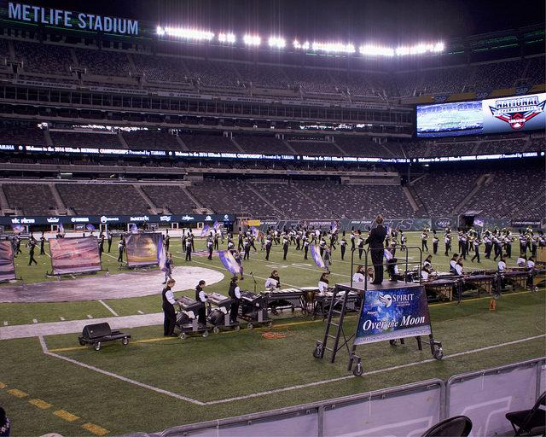

SHOW THEME
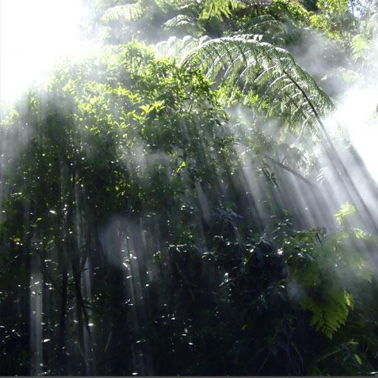
RAIN FOREST
http://visaud.io/portfolio-item/rain-forest-band/
MUSIC BY BRYAN T. HARMSEN
VISUAL DESIGN BY TONY CIMINO
COLORGUARD DESIGN BY JENNIFER C. MCPHERSON

