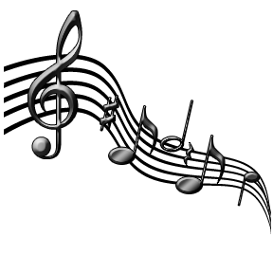
FHS Band Boosters Meeting – Monday, September 12, 2016
Attendees: | Ji-Hyun Ahn Susan Stefano  Mark Scheyder Yu Wang  Julie Abel Kim Richards  Laurie Graves Lisa Wood  Carolyn Ubelhart Greg Alonso  Scott Philben  Shannon Dingus  Rebecca Macias  Christina Danford | Important Dates: | Home Football Games: Sept. 16 & 30  Super Saturday: 9/17, 8am-4pm  USBands Competition, Herndon: 9/24  USBands Competition, Annapolis: 10/1  Next Boosters Meeting: 10/11

Meeting Opened by Ji-Hyun Ahn at: 7:05
VP Operations Report: Ji-Hyun Ahn
- Tag Day: $15,680 was the total of funds raised. 63.7% goes to the band =$10,600
- Mattress Sale: $5,550 was raised
- Susan Bean is working on organizing a parent bus for NJ – details will be sent out soon.
- From Volunteer perspective – all is looking good this year.
- Restaurant Nights: 10/18 Los Toltecas, 12/7 Moe’s – Julie Abel is working on Dairy Queen for Sept.
- Banners for the show are being donated by Fast Signs
- Super Saturday this Sat. (9/17) 8am-4pm – group pic w/ guard in uniforms on Sat.
- Working out kinks with Jersey Mike’s order for game nights
VP Logistics Report: Mark Scheyder
- Herndon competition is coming up – we’ll figure out the equipment situation then (ie: how many vehicles we’ll need)
Fundraising Report:
- Fall (Oct/Nov) Krispy Kreme Donut fundraiser – Susan Stefano is working on organizing
Spirit Wear Report: Shannon Dingus
- Di Hill spirit wear order being distributed now
- Fast Signs spirit wear order to be distributed on Friday, 9/16
- Another spirit wear order going out 9/19 – show shirt hoodie & “gametime” t-shirt added (items will be received mid-Oct)
VP Guard Report: Lisa Wood
- Uniforms & makeup are in
- Building up to competition readiness
- Half Moon tarp has been ordered & will be in before Herndon competition
Meeting closed by JiHyun Ahn at 7:30pm
Next Meeting Date: Monday, October 11, 2016

